Flagged for Life Social Media Toolkit

Background
LatinoJustice PRLDEF has released a report on “gang” labeling, policing, and surveillance practices in Nassau County, Long Island, New York. The report’s findings reveal how Freeport Village Police Department and Nassau County Police Department secretly, arbitrarily, and overbroadly label Black and Latinx residents as “gang members” without due process protections and often without evidentiary support. These inaccurate and stigmatizing methods of gang labeling are racial profiling and lead to increased police targeting and surveillance of the county’s Black and Latinx communities.

Link to report PDF | Link to report on website

Call to Action
We demand Nassau County police comply with the law!
- End unnecessary stops and searches for “looking like a gang member.”
- End secret lists without notification and a right to challenge inclusion.
- This is racial profiling, and it must stop!

Share this toolkit and our report with your network to amplify the message that our families, children, and neighbors deserve to live free from the threat of being #flaggedforlife.

Below you will find graphics and messaging that you can share to better inform your audience and the community about the findings of this report. By amplifying our voices together, we can serve as digital advocates to hold law enforcement accountable to the law.

Tag Us

Twitter
@LatinoJusticePRLDEF

Instagram
@LatinoJustice

Facebook
@LatinoJustice

Hashtag
#FlaggedForLife

Graphics
Use the graphics below to share on your social media accounts!
Download Here
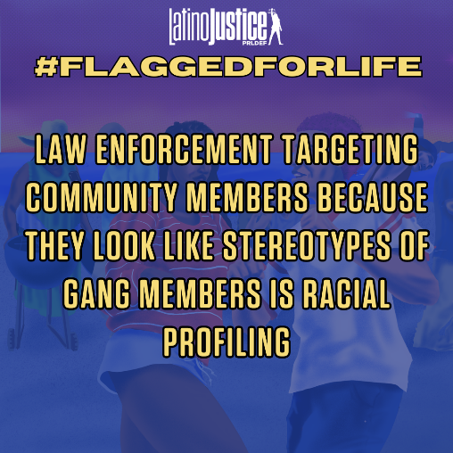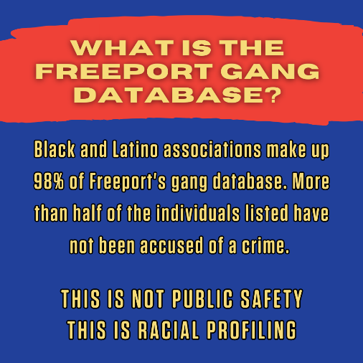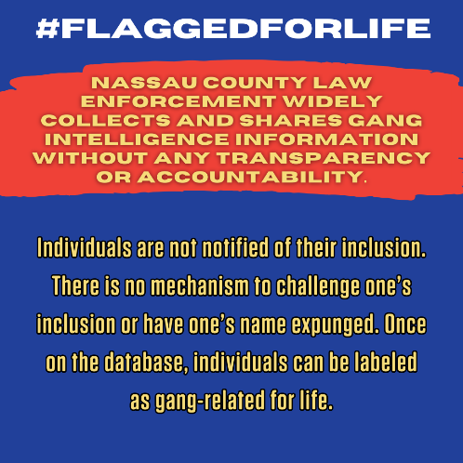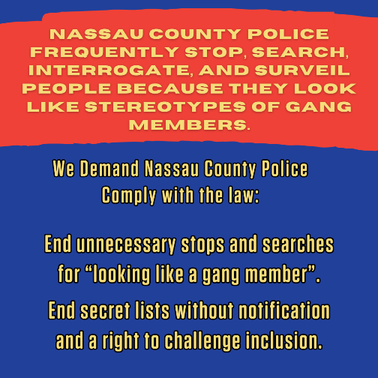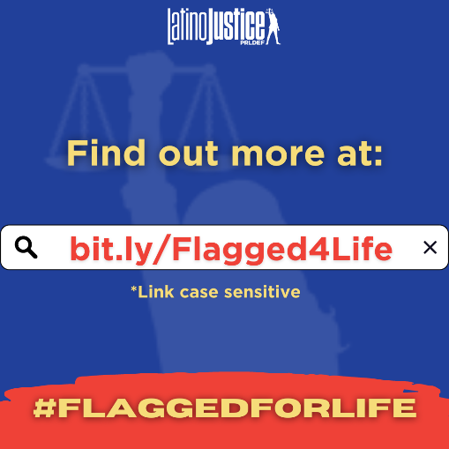

Sample tweets and captions:
- “🚨 NEW REPORT 🚨 Our communities are under surveillance. @LatinoJustice uncovered secretive networks of gang intelligence sharing between law enforcement agencies in Nassau County. We denounce these tactics. Our communities deserve freedom of association.” bit.ly/Flagged4Life
- “Gang allegations are arbitrary, overbroad, & racially biased. Law enforcement labeling a group as a “gang” is frequently unsupported by evidence. The overrepresentation of Black & Latinos on gang databases is evidence that "gang" designation is biased & targets minority groups.” bit.ly/Flagged4Life
- We demand an end to racialized policing and that Nassau County police immediately comply with the law! Our families, children, and neighbors deserve to live free from the threat of being #FlaggedForLife” bit.ly/Flagged4Life
- “A must-read report! LJP shows the racialized surveillance methods of local police departments. And THIS is why we clamor for justice. Because our people are facing injustice. #FlaggedForLife!
bit.ly/Flagged4Life

“End the ongoing racial profiling & criminalization of association via gang policing. Hyper surveillance policing methods in suburban communities like Long Island have avoided public scrutiny. End gang databases criminalizing Black & Brown people! #FlaggedForLife” bit.ly/Flagged4Life

